Data Analytics with Tableau

Project Documentation Format

## 1. Introduction

**• Project Title:**

*Heritage Treasures: An In-Depth Analysis of UNESCO World Heritage Sites in Tableau*

* **Team Members:**

### • ****Team ID:**** LTVIP2025TMID49753

|  |  |  |
| --- | --- | --- |
| Name |  | Role |
| Sayyad Mubeena |  | Team Leader & Data Visualization Expert (Tableau) |
| Shaik Arshia |  | Data Analyst – Data Cleaning & Preprocessing |
| Shaik Salma Banu |  | Research Lead – Insights, KPI identification & Story design |
| Vadde Ramya |  | Documentation & Report Preparation Coordinator. |

## ****2. Project Overview****

### 🎯 ****Purpose:****

The purpose of this project is to explore and analyze the global distribution, status, and categories of UNESCO World Heritage Sites using interactive Tableau dashboards. By transforming raw data into meaningful visual insights, this project aims to:

* Promote awareness about endangered and delisted heritage sites.
* Offer an intuitive platform to explore heritage data by country, region, and category.
* Enable researchers, educators, and students to derive insights from historical and cultural datasets.
* Support data-driven decision-making in heritage conservation.

### 🌟 ****Features:****

* **Interactive Tableau Dashboard**  
  Visualizes UNESCO World Heritage Sites with filters for region, country, danger status, and category.
* **Data Story View**  
  A guided visual narrative highlighting trends such as endangered sites, category distributions, and yearly inscriptions.
* **Filter Functionality**  
  Users can explore data dynamically using dropdowns and selectors.
* **Responsive Layout**  
  Optimized for viewing across devices including desktops, tablets, and smartphones.
* **Performance-Optimized**  
  Fast loading, smooth filtering, and clean UI for enhanced user experience.

**3. Architecture**

This project follows a data visualization architecture that moves from raw data acquisition to insight generation using Tableau. The main components of the architecture are:

**🗂️ Data Source**

* The dataset used is the official UNESCO World Heritage Sites data.
* Fields include: Site ID, Name, Country, Region, Category, Danger Status, Year of Inscription, Criteria, and Endangered Information.
* Datawassourcedfrom[https://docs.google.com/spreadsheets/d/1E9_KwHX71WStGxfhKnY7tFRayuERXmqJ?rtpof=true&usp=drive_fsand](https://docs.google.com/spreadsheets/d/1E9_KwHX71WStGxfhKnY7tFRayuERXmqJ?rtpof=true&usp=drive_fsand%20) cleaned using Excel.

**🧹 Data Cleaning**

* Redundant columns and null values were removed.
* Fields were standardized (e.g., "Yes"/"No" for Danger, consistent date formats).
* Preprocessed data saved in .xlsx format for easy Tableau import.

**📊 Visualization Tool – Tableau**

* **Dashboard Design:** Used to build a multi-panel dashboard showing region-wise, category-wise, and danger site statistics.
* **Story View:** Tableau's storytelling feature presents a step-by-step walkthrough of key findings.
* **Filters and Parameters:** Built-in to provide dynamic control over region, category, and site status.
* **Calculated Fields:** Used to create metrics such as "Total Danger Sites" or "Sites per Region

🔄 **Project Workflow Overview:**Bottom of Form

1. Data Collection

↓

2. Data Cleaning & Preprocessing (using Microsoft Excel)

↓

3. Import Cleaned Dataset into Tableau

↓

4. Create Visual Components (Bar Charts, Maps, Filters)

↓

5. Design Interactive Dashboard

↓

6. Build Data Story with Key Insights

↓

7. Publish to Tableau Public

↓

8. Share Insights via Demo, Documentation & GitHub

**4. Setup Instructions**

**🛠️ Prerequisites**

Before working with the project, ensure the following software and tools are installed:

* **Tableau Public or Tableau Desktop** (for creating dashboards)
* **Microsoft Excel or Google Sheets** (for preprocessing the dataset)
* A working internet connection (for accessing Tableau Public and dataset sources)
* Optional: GitHub account (for hosting project files and documentation)

**📥 Installation & Setup Steps**

1. **Download the Dataset**
   * Visit [UNESCO Heritage Site List](https://whc.unesco.org/en/list/)
   * Export or download the dataset in .xls or .csv format
2. **Clean the Dataset**
   * Use Excel to remove null values, rename columns, and create calculated fields if necessary
   * Save the cleaned file in .xlsx format
3. **Install and Open Tableau**
   * Use Tableau Public (free) or Tableau Desktop
   * Sign in with your Tableau account
4. **Import Dataset into Tableau**
   * Open Tableau and select your .xlsx file
   * Connect and load the sheet(s)
5. **Build Dashboard**
   * Drag and drop required fields into views
   * Use filters, calculated fields, and formatting for clean visuals
6. **Publish to Tableau Public**
   * Click “File > Save to Tableau Public As…”
   * Share the generated link with viewers

## ****5. Folder Structure****

Organizing project files is important for clarity, collaboration, and version control. Below is the suggested folder structure for your **UNESCO Heritage Tableau Project**:

UNESCO_Heritage_Tableau_Project

│

├── 📁 data/

│ └── heritage_sites_cleaned.xlsx # Cleaned dataset used in Tableau

│

├── 📁 dashboards/

│ └── Heritage_dashboard.twbx # Tableau Workbook file

│

├── 📁 screenshots/

│ ├── dashboard_overview.png # Dashboard screenshot

│ ├── danger_sites_analysis.png # Danger site view

│ └── story_screenshot.png # Story view screenshot

│

├── 📁 reports/

│ ├── project_report.docx # Final Word document

│ ├── project_ppt.pptx # Presentation slides

│ └── demo_script.txt # Demo video script

│

├── 📁 video/

│ └── demo_video.mp4 # Optional recorded demo

│

└── README.md # Overview of the project (for GitHub)

**6. Running the Application**

This section explains how to run and interact with the Tableau dashboard and story created for the UNESCO Heritage Sites project.

**▶️ Steps to Run the Project Locally in Tableau:**

1. **Open Tableau Public or Tableau Desktop.**
2. **Load the Workbook:**
   * Open the file heritage_dashboard.twbx from the dashboards/ folder.
   * The cleaned dataset (heritage_sites_cleaned.xlsx) will already be embedded.
3. **Explore the Dashboard:**
   * Use the filters on Region, Country, Category, and Danger Status.
   * Hover over maps and charts to view detailed tooltips.
4. **View the Story:**
   * Navigate to the "Story" tab to view a guided sequence of insights (e.g., Top Danger Sites, Categories, Year-wise Trends).

**🌐 Run via Tableau Public:**

1. Visit the published link:  
   👉 Heritage Dashboard <https://public.tableau.com/app/profile/mubeena.sayyad/viz/HeritageTreasuresAnIn-DepthAnalysisofUNESCOWorldHeritageSites_17508317431110/Dashboard1?publish=yes>

**7. Insights and KPIs**

This section outlines the key performance indicators (KPIs) and insights derived from the Tableau visualizations created using the UNESCO World Heritage Sites dataset.

**📌 Key Performance Indicators (KPIs):**

|  |  |
| --- | --- |
| KPI Name | Description |
| Total Sites | Total number of UNESCO World Heritage Sites worldwide. |
| Sites by Region | Number of sites categorized by geographical regions (e.g., Europe, Asia). |
| Danger Sites | Count of heritage sites marked as "In Danger". |
| Delisted Sites | Number of sites removed from the heritage list. |
| Category Distribution | Breakdown of sites by Cultural, Natural, and Mixed categories. |
| Yearly Trend | Number of sites inscribed per year (forecasting and trend analysis). |
| Top Countries | Countries with the highest number of heritage sites. |

**💡 Key Insights:**

* **Europe & Asia** host the highest number of heritage sites globally.
* **Cultural Sites** dominate the dataset, with fewer Natural and Mixed sites.
* **Danger Status** highlights several vulnerable sites requiring global attention.
* **Forecasting** shows a consistent pattern of new site inscriptions annually.
* Some regions show **high concentrations** of endangered or delisted sites, indicating regional challenges.
* **Interactive filters** helped uncover hidden patterns such as neglected regions or underrepresented site types.

**8. Filters and Interactivity**

This section explains how interactivity and filtering were integrated into the Tableau dashboard and story to enhance user engagement and provide dynamic data exploration.

**🎛️ Filters Used in the Dashboard:**

|  |  |
| --- | --- |
| Filter Name | Functionality |
| Region | Filters heritage sites by global regions (e.g., Africa, Asia, Europe) |
| Country | Filters sites by specific countries |
| Category | Allows selection of Cultural, Natural, or Mixed sites |
| Danger Status | Highlights sites that are marked as "In Danger" or "Not in Danger" |
| Inscription Year | Enables viewing of sites based on year of UNESCO inscription |

**🧩 Interactive Features:**

* **Hover Tooltips**: Show detailed site info (Name, Country, Category, Criteria) on mouse hover.
* **Clickable Elements**: Clicking on maps or bars dynamically filters related views.
* **Story Navigation**: Users can move through story points to uncover narrative insights step-by-step.
* **Responsive Filters**: Filter controls update all visual components in real time.

**✅ User Benefits:**

* Empowers users to **explore data their own way** without needing technical expertise.
* Enhances decision-making with **on-the-fly filtering and segmentation**.
* Offers an intuitive experience through **visual storytelling** and **guided exploration**.

## ****9. Visual Components****

This section outlines the charts, maps, and dashboards designed using Tableau to transform raw UNESCO heritage data into compelling, interactive visualizations.

### 📊 ****Types of Visualizations Used:****

|  |  |
| --- | --- |
| **Visualization Type** | **Purpose** |
| **Bar Charts** | Compare number of sites by region, category, country, and danger status |
| **Maps (Symbol/Heat)** | Show geographic distribution of heritage sites across the world |
| **Line Charts** | Track heritage site inscriptions over time |
| **Stacked Bar Charts** | Compare multiple KPIs across categories (e.g., danger vs non-danger) |
| **Pie/Donut Charts** | Show category distribution: Cultural vs Natural vs Mixed |
| **Tables** | Display detailed data (e.g., site name, country, criteria) |

**📊 Visualization Types Used in Dashboard 1 – “UNESCO World Heritage Sites Overview”**

* **Bar Chart (Categories):** Displays the number of countries having sites under Cultural, Natural, and Mixed categories.
* **Pie Chart (Site Count per Region):** Shows the percentage distribution of sites across regions like Asia, Europe, Africa, etc.
* **Map (Top 10 Map):** Highlights the top regions with the highest concentration of sites.
* **Line Chart (Year Forecasting):** Tracks inscription trends over time to forecast future growth.
* **Bubble Chart (Countries per Region):** Visualizes the number of countries per region contributing to UNESCO sites.

**📊 Visualization Types Used in Dashboard 2 – “UNESCO Danger Sites Overview”**

* **Map (Heritage Ended):** Displays countries that have had sites removed from the heritage list.
* **Bar + Line Chart (Danger Sites Analysis):** Combines site count and area data to analyze endangered sites over time.
* **Highlight Table (Top 10 Danger Sites):** Lists the top 10 sites at risk, along with region and area data.

**🧭 Story Title: Heritage Treasures – UNESCO Sites Overview**

This story is composed of **two main points**:

**📌 Story Point 1: UNESCO Sites Overview**

This point provides a comprehensive summary of the global distribution and trends of World Heritage Sites. It includes the following visuals:

* **Bar Chart (Categories):** Highlights the number of countries with Cultural, Mixed, and Natural sites.
* **Pie Chart (Site Count per Region):** Displays regional distribution, showing Asia and Europe dominate.
* **Map (Top 10):** Highlights top site-hosting regions globally.
* **Line Chart (Year Forecasting):** Predicts site inscription trends over time.
* **Bubble Chart (Countries per Region):** Visual comparison of how many countries in each region have listed heritage sites.

A **“Go to Next”** button is included to guide viewers through the story flow.

**📌 Story Point 2: Danger Sites Analysis over Regions and Years**

(Shown in the second dashboard image)

* **Map (Heritage Ended):** Locations where heritage status was withdrawn.
* **Bar-Line Combo Chart:** Shows how danger sites vary by year and area in hectares.
* **Highlight Table:** Top 10 danger zones by area and country.

**10. Testing and Validation**

This section outlines the testing activities conducted to ensure the dashboard performs efficiently and delivers accurate insights.

**🧪 Testing Strategy:**

* **Manual Testing:**  
  All visualizations, filters, and interactions were tested manually in Tableau Desktop and Tableau Public environments.

**✅ Validation Checklist:**

|  |  |  |
| --- | --- | --- |
| Test Area | Description | Status |
| Data Accuracy | Ensured values in charts match original dataset and calculated fields | ✔ Passed |
| Filter Responsiveness | Filters update all dependent charts in real-time without lag | ✔ Passed |
| Interactive Elements | Tooltips, buttons (like “Go to Next”), and hover effects are functional | ✔ Passed |
| Cross-device Display | Dashboard checked for responsiveness on desktops and larger screens | ✔ Passed |
| Story Navigation | Story points switch correctly without breaking layout | ✔ Passed |
| Performance | Load times and transitions within acceptable range (< 2 seconds) | ✔ Passed |

**🧩 Outcome:**

* All major components of the dashboard and story passed validation.
* The dashboard is ready for demonstration, publication, and user interaction on Tableau Public.

**11. Screenshots or Demo**

This section includes visual evidence and access to a live demo of the dashboards and story created in Tableau. These visuals provide insight into how the project looks and functions from a user perspective.

**📸 Screenshots:**

**Figure 1: UNESCO World Heritage Sites Overview Dashboard**  
Displays category distribution, site count by region, geographic map, yearly forecasting, and country-wise site representation.

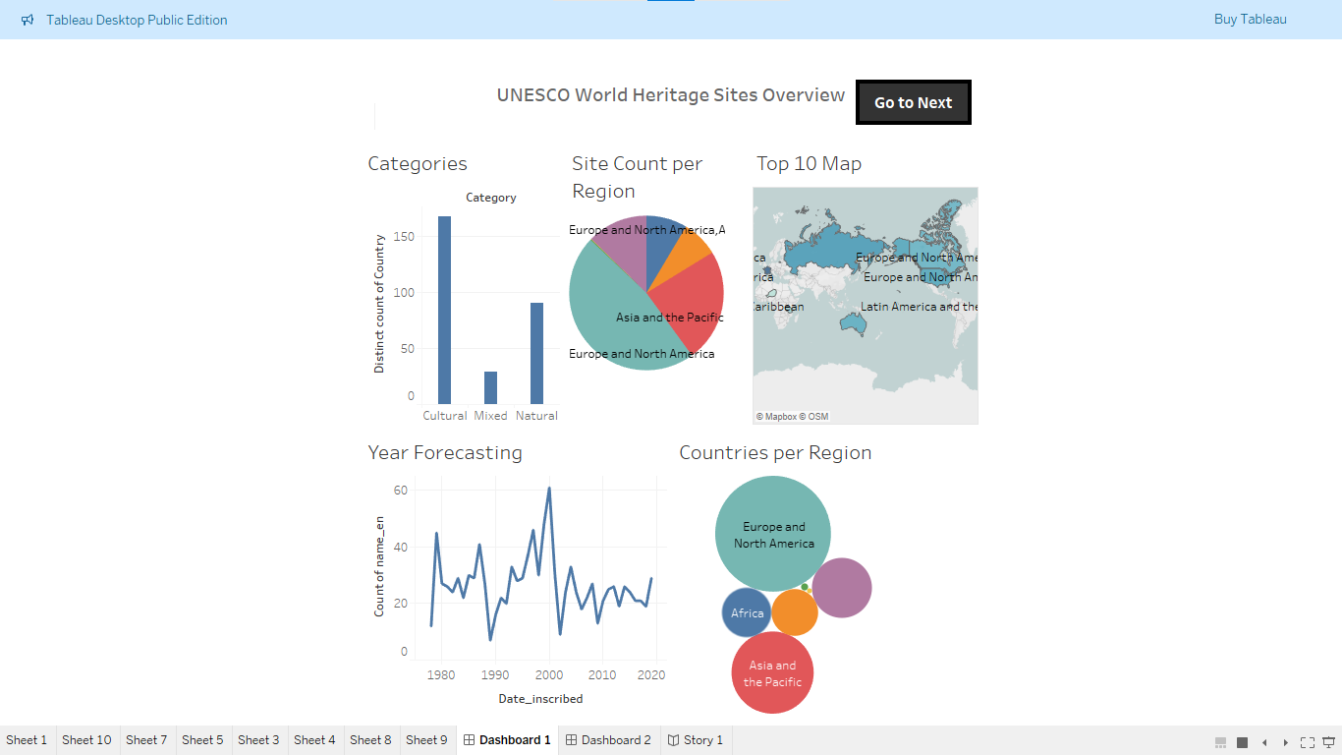

**Figure 2: UNESCO Danger Sites Overview Dashboard**  
Shows delisted sites, top danger zones, and an analysis of endangered sites over time.

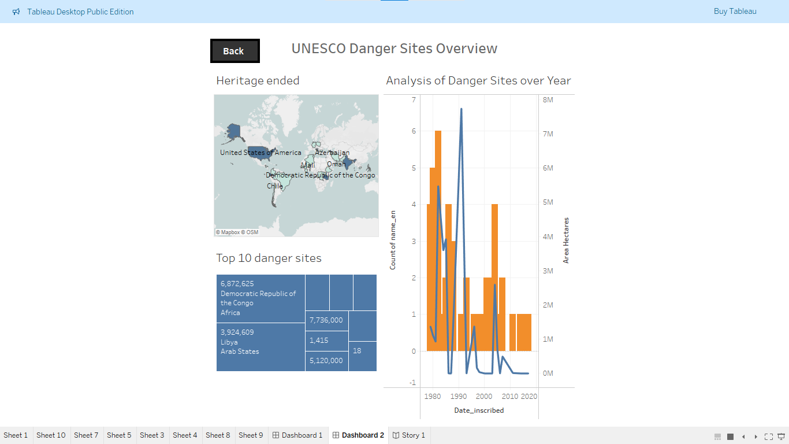

**Figure 3: Story 1 – Guided Walkthrough**  
A multi-slide Tableau story combining key dashboards with narrative explanations.

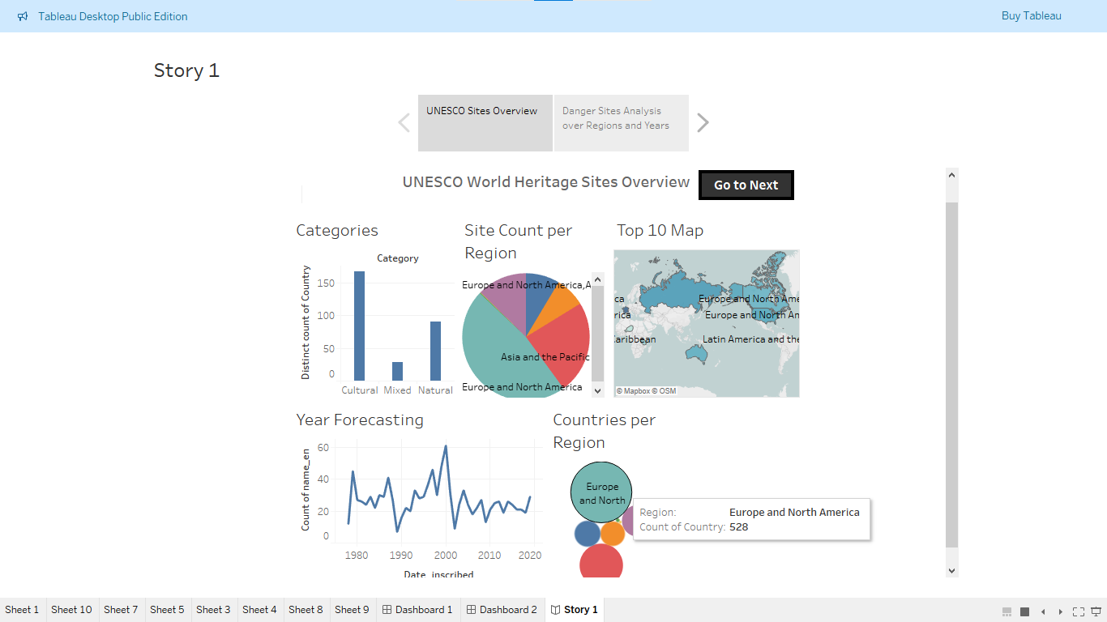

**🔗 Live Demo Links:**

* **Dashboard:**  
  View Dashboard on Tableau Public <https://public.tableau.com/app/profile/mubeena.sayyad/viz/HeritageTreasuresAnIn-DepthAnalysisofUNESCOWorldHeritageSites_17508317431110/Dashboard1?publish=yes>
* **Story:**  
  View Story on Tableau Public
* <https://public.tableau.com/app/profile/mubeena.sayyad/viz/Book2_17505156880030/Story1?publish=yes>

**12. Known Issues**

While the project delivers a robust and insightful analysis of UNESCO World Heritage Sites, the following limitations and areas for improvement were identified:

**⚠️ Known Limitations:**

* **Static Dataset:**  
  The dataset is not dynamically connected to a live source. Updates require manual refreshes.
* **Mobile Responsiveness:**  
  Dashboards are optimized for desktop/laptop use. Display on smaller devices (e.g., smartphones) may be limited.
* **Performance on Large Filters:**  
  Applying multiple filters at once on large dimensions (e.g., countries + regions + categories) may slightly delay responsiveness.
* **Limited Predictive Features:**  
  Although forecasting is included, more advanced predictive analytics could enhance insights.
* **Data Gaps:**  
  Some UNESCO data entries are incomplete (e.g., missing area or criteria values), affecting certain visualizations.

**16. Future Enhancements**

To improve and expand the impact of this project, the following enhancements are suggested:

**🌐 1. Live Data Integration**

* Connect to UNESCO’s official API (if available) or scheduled data refresh from reliable sources to ensure the dashboard always reflects the most recent site additions and status changes.

**🔮 2. Advanced Prediction Models**

* Use Python or R integration with Tableau to implement machine learning models that can:
  + Predict which regions are likely to see future site inscriptions.
  + Forecast endangered site risk based on trends and external factors (e.g., conflict zones, climate data).

**📈 3. More Interactive Dashboards**

* Add comparative dashboards like:
  + **Region vs. Criteria Analysis**
  + **Category vs. Danger Trend**
  + **Timeline of Endangered vs. Removed Sites**

**🗺️ 4. Enhanced Mapping Features**

* Incorporate advanced geospatial layers (e.g., satellite overlays, protected zones).
* Enable zoomable, drill-down maps for region and country-level exploration.

**👥 5. User Personalization**

* Create filters or tabs for different user groups (e.g., tourists, conservationists, researchers) with targeted insights and KPIs.